**ASSIGNMENT-10**

**Problem Statement: Deploy a project from GitHub to EC2 by creating a new security group and user data.**

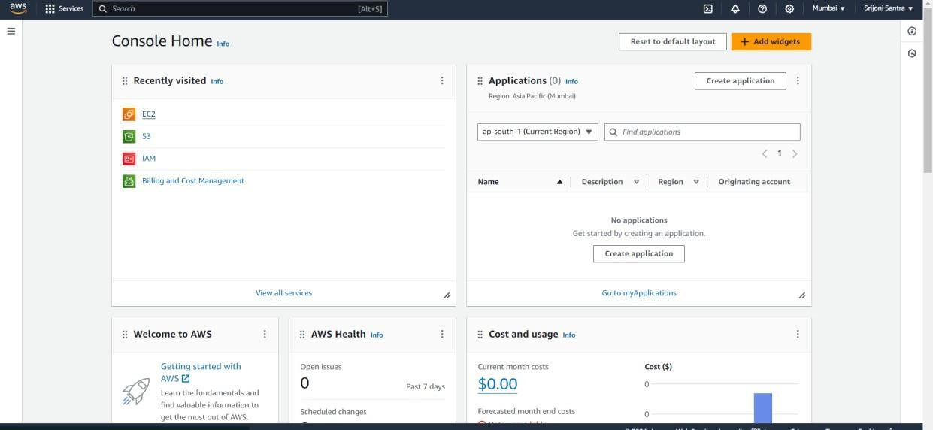

**Step 1:** Login to the console and click on **EC2**.

**Step 2:** Then click on Security Groups

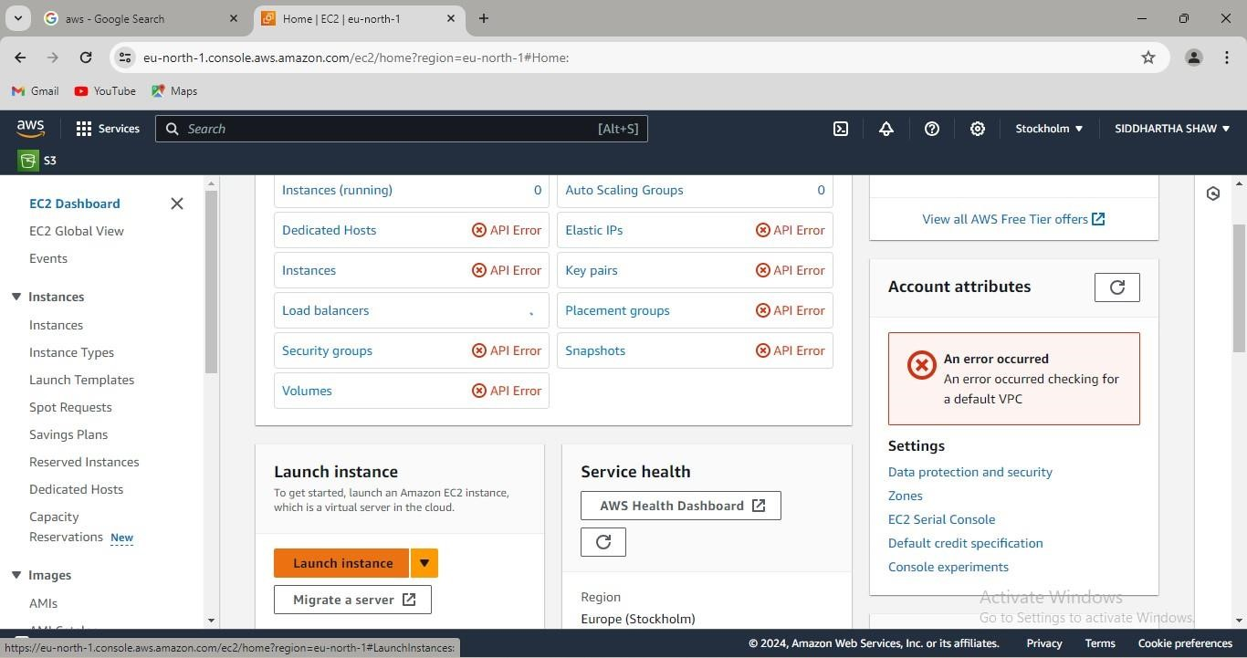

**Step 3**: Then go to the “Create Security group”

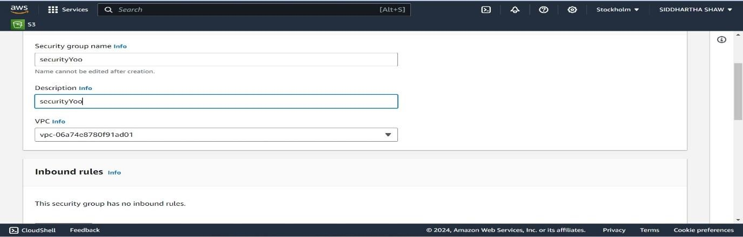

**Step 4:** Write security group name, add inbound rules and click on “Create security group”.

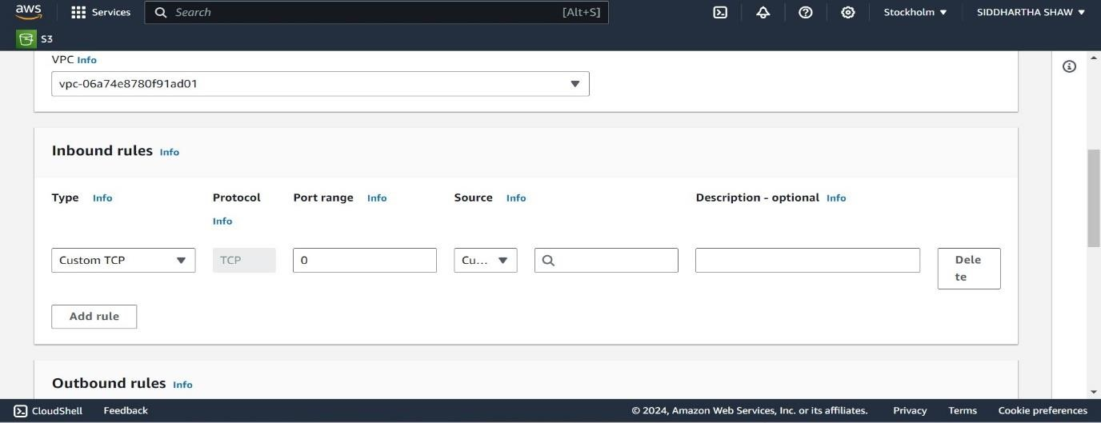

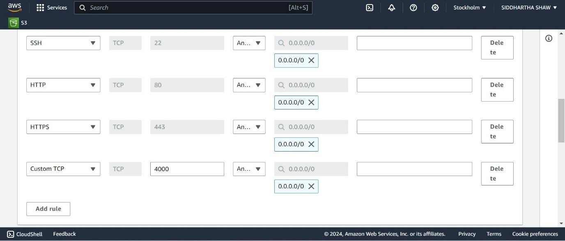

**Step 5**: after that security group is created successfully.

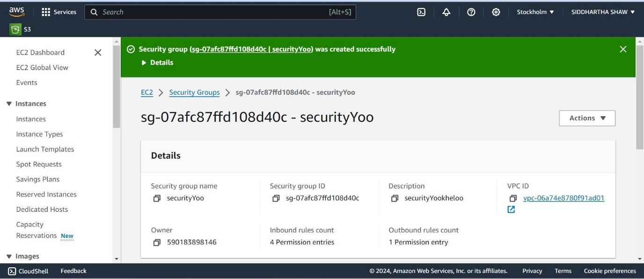

**Step 6**: The security group is created. Now go to the EC2 and click on “Launch Instances”.

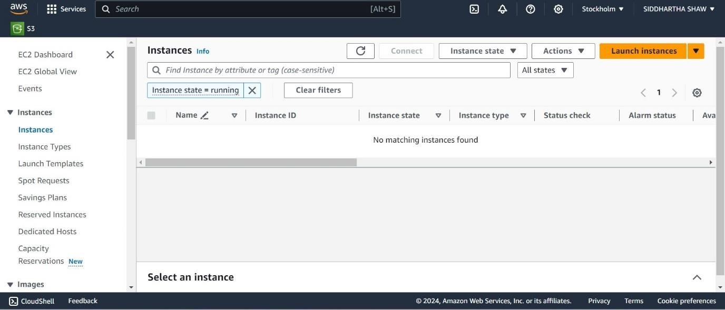

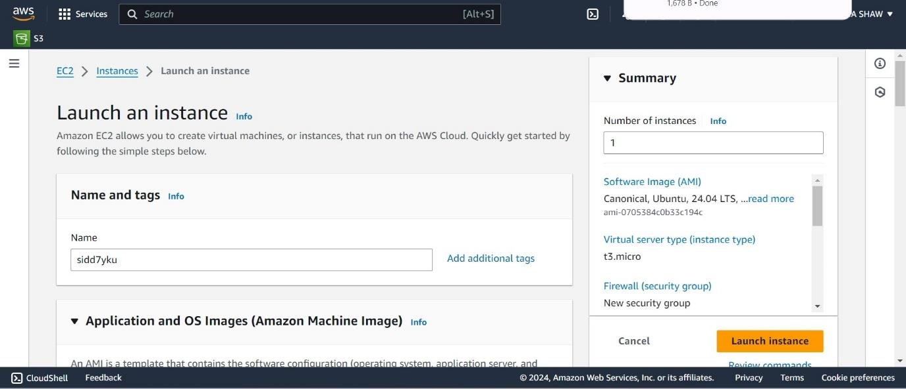

**Step 7:** create the key pair and go the further steps.

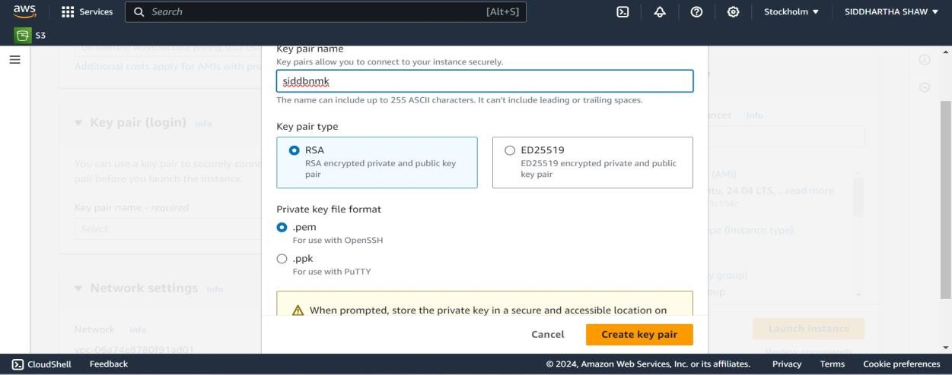

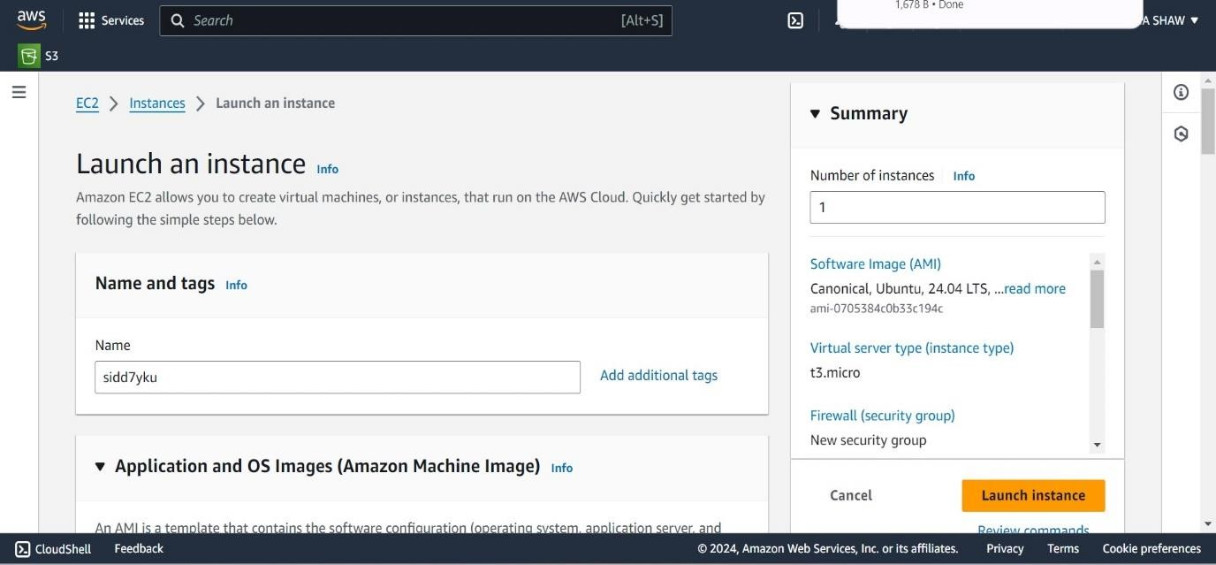

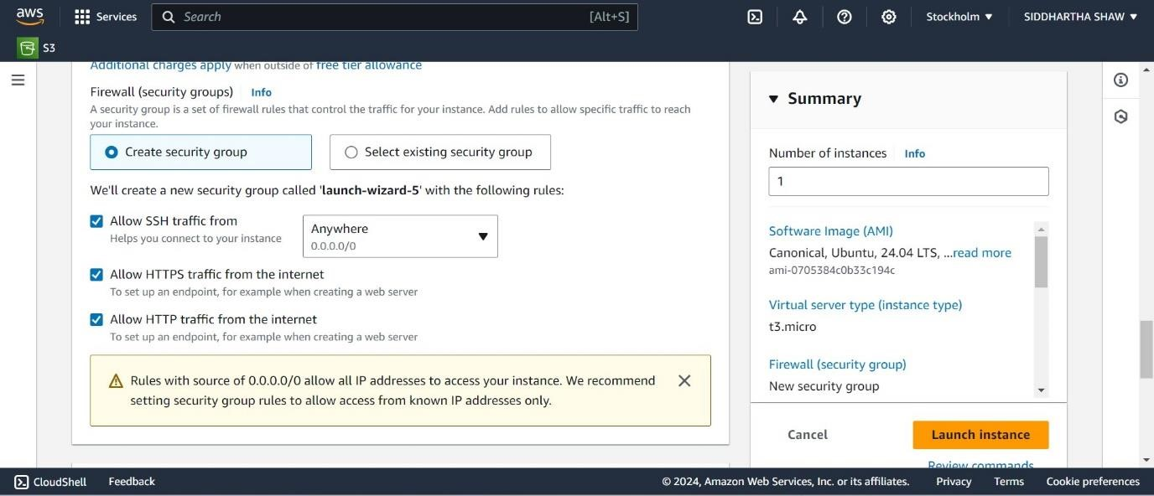**Step 8:** select the SSH, HTTPS,HTTP and move it.

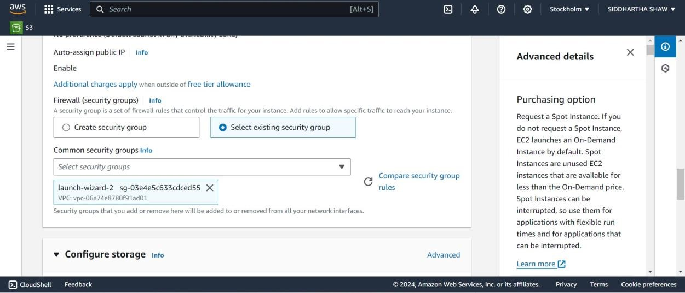**Step 9:** Select the option “Select existing security group” and choose the newly created security group.

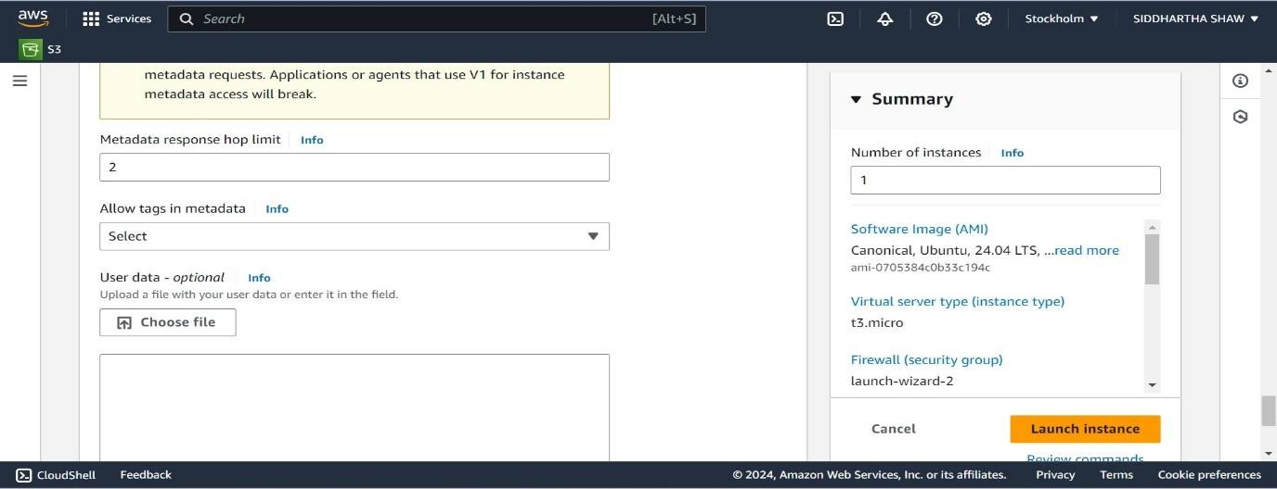

**Step 10:** Then click on the “advanced details” & write the commands and click on “Launch Instances”.

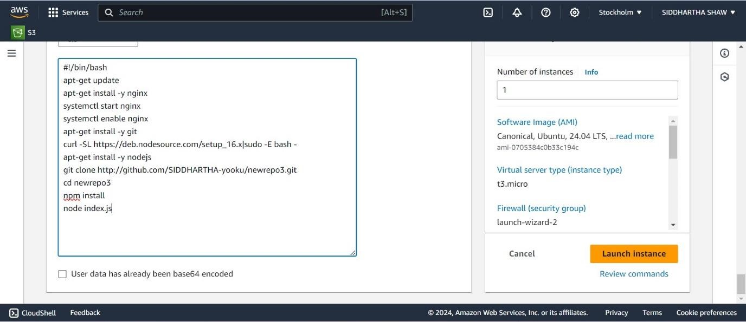

**Step 11: a**fter that the instance lunch successfully.

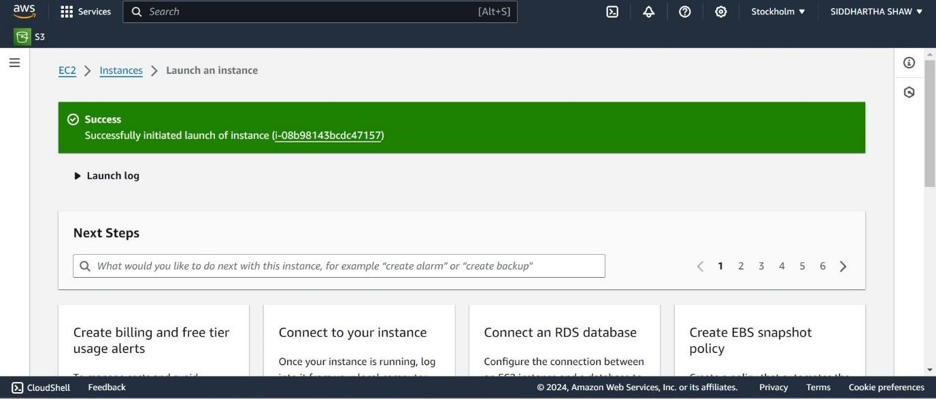

**Step 12:** now we go the view instance and copy the public i**pv4** adresss to check whether it is run or not.

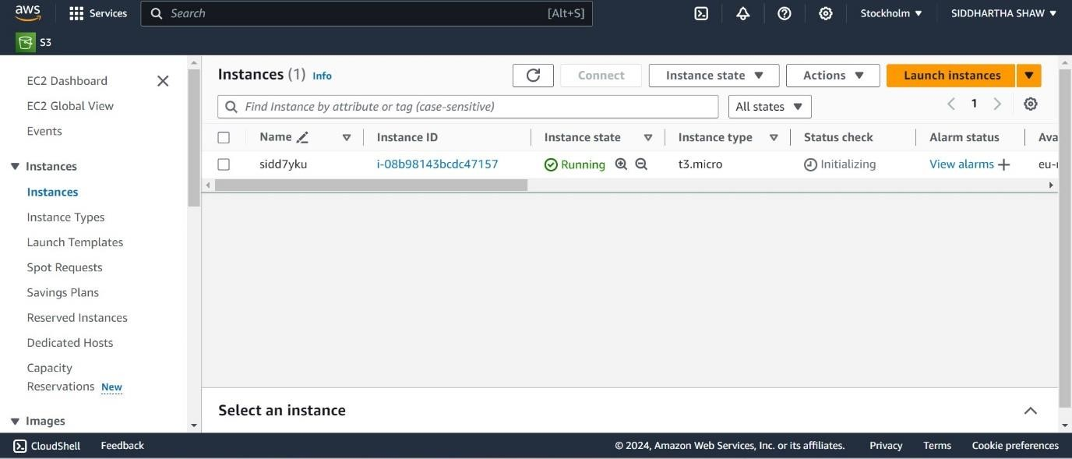



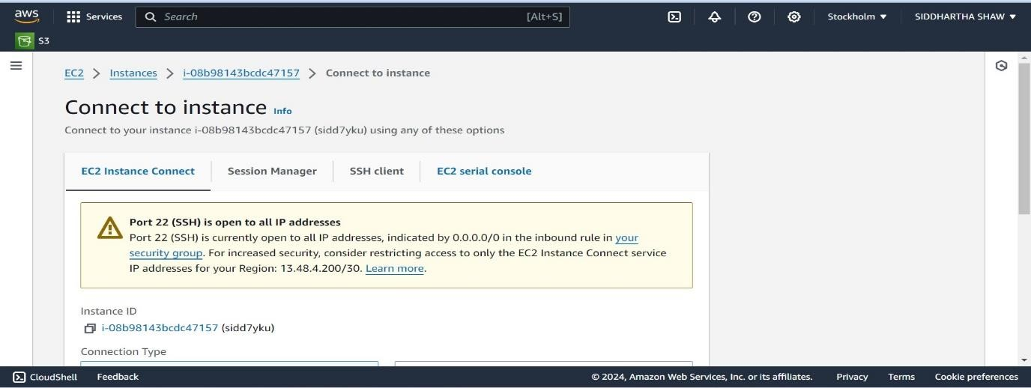**Step 13:** if it is showing not running then we use 2nd method whether we go to the **“connect to instance”..**and then type such impo** commands that are given below.

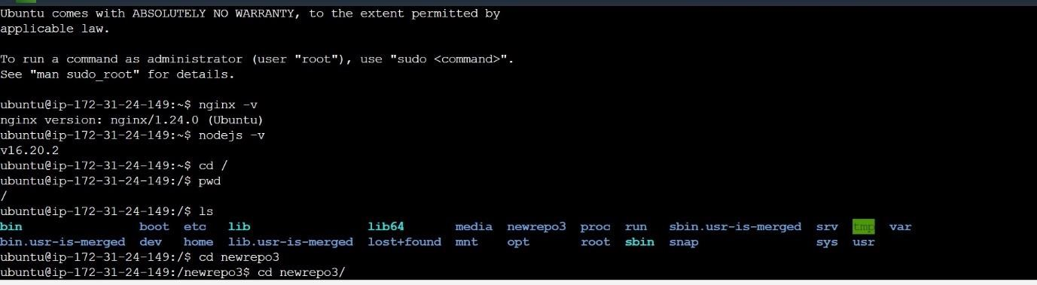

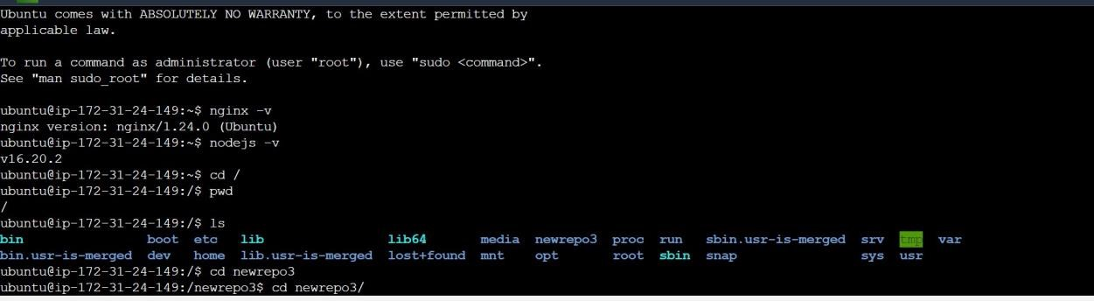

**Step 14:** After creating the instances copy public IPV4 address and paste in the new tab with the 4000 port no.

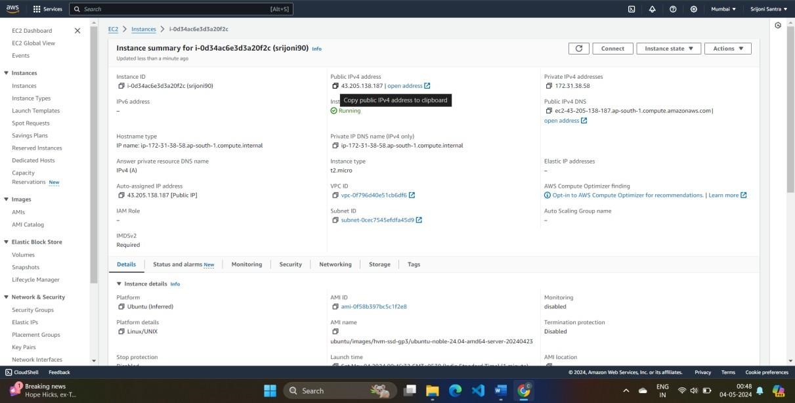

**Step 15:** A new window will open with the webpage.

